Comprehensive Data Science Report and Insights Presentation Plan
Project: Customer Churn Prediction
Prepared by: Krishnapriya K V
Internship: Virtual Data Science Explorer Intern
Task: Week 4 – Comprehensive Data Science Report and Insights Presentation Plan

1. Executive Summary
Customer churn is a common problem faced by subscription-based and service-based businesses. It occurs when customers stop using a service or cancel their subscription. Predicting customer churn can help a company identify customers who may leave and take suitable actions to improve customer retention.
This project focuses on developing a data science approach for predicting customer churn. The proposed approach includes understanding customer information, cleaning and preprocessing the data, performing Exploratory Data Analysis (EDA), developing machine learning classification models and evaluating their performance.
The main customer information considered in the project includes tenure, monthly charges, plan type, contract type, payment method, support calls and churn status. These features can help identify patterns that may be associated with customer churn.
For this final report, hypothetical findings are used to demonstrate how the results could be presented to business stakeholders. For example, the analysis may show that customers with shorter tenure or a higher number of support requests have a higher risk of churn. These findings could help the company focus retention efforts on customers who need more attention.
The report also presents mock-up tables and visualization plans that can be used to communicate the results. The final section explains how technical findings can be presented to non-technical stakeholders using simple language, clear charts and a logical storytelling approach.
Since no real dataset was provided, the findings, numbers and examples in this report are illustrative and should not be considered actual model results.

2. Project Background
Customer retention is important for many businesses because acquiring a new customer can require more effort and resources than retaining an existing customer.
A customer may stop using a service for several reasons, such as:
- High service cost
- Poor customer support
- Unsuitable subscription plan
- Lack of usage
- Payment difficulties
- Better offers from competitors
- Dissatisfaction with the service
Data science can be used to study customer information and identify patterns related to churn.
The purpose of this project is to design a data science solution that can help predict which customers may be at risk of leaving.

3. Problem Statement
The main problem is to predict whether a customer is likely to churn based on available customer information.
The target variable is:
Churn = Yes / No
Therefore, the problem can be treated as a binary classification problem.
A possible system would take customer information as input and produce a prediction such as:
Customer → High Churn Risk
or
Customer → Low Churn Risk
The prediction can then be used as supporting information for customer retention decisions.

4. Project Objectives
The main objectives of the project are:
- Understand customer data.
- Identify factors that may be related to churn.
- Clean and preprocess the available data.
- Perform Exploratory Data Analysis.
- Identify important patterns and relationships.
- Develop classification models.
- Evaluate and compare model performance.
- Identify customers who may have a higher churn risk.
- Convert technical findings into understandable business insights.
- Suggest possible actions for improving customer retention.

5. Methodology Overview
The proposed methodology follows a structured data science workflow.
Step 1 – Problem Understanding
The first step is to clearly define customer churn and determine what the model should predict.
Step 2 – Data Collection
Customer information such as tenure, monthly charges, plan type, support requests and contract type can be collected.
Step 3 – Data Cleaning
The data will be checked for:
- Missing values
- Duplicate records
- Incorrect values
- Incorrect data types
- Unusual values
Step 4 – Exploratory Data Analysis
The data will be explored using statistical summaries and visualizations.
Step 5 – Data Preprocessing
Categorical variables will be encoded and numerical features may be scaled where required.
Step 6 – Feature Selection
Useful features will be selected based on their relevance to the prediction problem.
Step 7 – Model Development
Classification models such as:
- Logistic Regression
- Decision Tree
- Random Forest
can be developed.
Step 8 – Model Evaluation
The models can be evaluated using:
- Accuracy
- Precision
- Recall
- F1-score
- Confusion Matrix
- ROC-AUC
Step 9 – Model Comparison
The results from different models can be compared to identify the most suitable approach.
Step 10 – Business Interpretation
The model results and EDA findings will be converted into simple business recommendations.

6. Data Description
The proposed customer dataset may contain the following variables:
Feature | Description | Type
Customer ID | Unique customer identifier | Identifier
Tenure | Number of months with the service | Numerical
Monthly Charge | Amount paid each month | Numerical
Plan Type | Customer subscription plan | Categorical
Contract Type | Type of customer contract | Categorical
Payment Method | Method used for payment | Categorical
Support Calls | Number of support requests | Numerical
Usage | Customer service usage | Numerical
Churn | Whether customer left | Binary
The Churn variable will be treated as the target variable.

7. Data Analysis Approach
The analysis would begin by checking the basic structure and quality of the dataset.
The following checks would be performed:
- Number of rows and columns
- Data types
- Missing values
- Duplicate records
- Unusual values
- Distribution of numerical variables
- Distribution of categorical variables
- Relationship between features and churn
For example, the number of customers in each churn category could be checked before building the machine learning model.

8. Hypothetical Findings
Since no actual dataset was provided, the following findings are hypothetical examples showing how results could be presented after a real analysis.
Finding 1 – Customer Tenure
Suppose the analysis shows that customers with shorter tenure have a higher churn rate than long-term customers.
For example:
Customer Group | Hypothetical Churn Rate
0–6 months | 32%
7–12 months | 24%
13–24 months | 15%
More than 24 months | 9%
This could indicate that newer customers may require additional attention during their early period with the company.
Important: These percentages are only mock values for demonstrating the presentation format.

9. Hypothetical Finding – Support Requests
Another possible finding could be that customers making a higher number of support requests have a greater likelihood of churn.
Example:
Support Calls | Hypothetical Churn Rate
0–1 | 8%
2–3 | 15%
4–5 | 25%
More than 5 | 38%
This could indicate that repeated support issues may be associated with customer dissatisfaction.
However, this relationship would need to be confirmed using actual data.

10. Hypothetical Finding – Monthly Charges
Monthly charges can also be compared with churn.
For example, suppose customers with higher monthly charges show a somewhat higher churn rate.
This could indicate that pricing or perceived value may influence customer decisions.
However, monthly charges alone should not be interpreted as the direct cause of churn. Other factors such as contract type, service quality and customer experience should also be considered.

11. Hypothetical Finding – Plan Type
A comparison between different plans can help identify whether churn patterns vary between customer groups.
Example:
Plan Type | Hypothetical Churn Rate
Basic | 18%
Standard | 13%
Premium | 21%

If such a pattern were found in actual data, further investigation would be required to understand why the Premium group has a higher churn rate.
Possible factors could include pricing, customer expectations or service usage.

12. Planned Visualization 1 – Churn Distribution
Chart Type:
Bar Chart
Purpose:
To show the number of customers who stayed and the number who churned.
Example:

Churn Status | Number of Customers
No | 750
Yes | 250
A bar chart would make it easy to understand the distribution of the target variable.
If the classes are highly imbalanced, this should be considered during model evaluation.

13. Planned Visualization 2 – Churn by Tenure
Chart Type:
Bar Chart
The chart would compare churn rates across different tenure groups.
Example:
0–6 months █████████████████
7–12 months ████████████
13–24 months ████████
24+ months █████
The exact chart values would come from the actual dataset.
Reason for choosing this chart
A bar chart makes it easy for a non-technical audience to compare different customer groups.

14. Planned Visualization 3 – Monthly Charges
Chart Type:
Histogram
A histogram can show how monthly charges are distributed among customers.
It can help identify:
- Common price ranges
- Very high or low charges
- Overall distribution
- Possible unusual values
The distribution could then be compared between customers who churned and those who stayed.

15. Planned Visualization 4 – Support Calls and Churn
Chart Type:
Box Plot
A box plot can be used to compare the number of support calls for customers who churned and customers who stayed.
This could help identify differences in the distributions and possible outliers.
For example, if customers who churned generally have more support calls, this could be an area for further investigation.

16. Planned Visualization 5 – Feature Relationship
Chart Type:
Heatmap
A correlation heatmap can be used to examine relationships between numerical variables.
Possible variables include:
- Tenure
- Monthly Charge
- Support Calls
- Usage
The heatmap can help identify variables that have stronger or weaker relationships.
However, correlation does not prove causation.

17. Planned Visualization 6 – Model Performance
Chart Type:
Bar Chart
After actual model training, the performance of different models could be compared.
Example format:
Model | Accuracy | F1-Score
Logistic Regression | To be calculated | To be calculated
Decision Tree | To be calculated | To be calculated
Random Forest | To be calculated | To be calculated
Actual values would only be entered after training the models on real data.

18. Key Insights
Based on the hypothetical analysis, the main areas that could require attention are:
1. New Customers
Customers who have recently joined may have a higher risk of leaving.
2. Frequent Support Requests
Customers with repeated support issues may have a greater churn risk.
3. Pricing
Higher monthly charges may be associated with churn for some customer groups.
4. Plan Differences
Different subscription plans may have different churn patterns.
5. Customer Behaviour
Combining multiple features may provide better information than considering a single feature.
These are hypothetical insights and would need to be confirmed using an actual dataset.

19. Actionable Recommendations
Based on the hypothetical findings, the following actions could be considered.
Recommendation 1 – Focus on New Customers
The company could create an onboarding program for new customers.
Possible actions:
- Welcome messages
- Setup assistance
- Early feedback collection
- Special introductory offers

Recommendation 2 – Improve Support Experience
Customers with repeated support requests could receive additional assistance.
Possible actions:
- Faster response times
- Follow-up calls
- Dedicated support
- Better problem tracking

Recommendation 3 – Review Pricing and Plans
If higher-paying customers show increased churn, the company could examine whether customers feel that the service provides enough value.
Possible actions:
- Flexible plans
- Discounts
- Additional benefits
- Customized offers

Recommendation 4 – Use Churn Risk for Customer Retention
After a model is properly developed and validated, customers with high predicted churn risk could be prioritized for retention campaigns.
The prediction should be treated as a supporting tool rather than an automatic decision.

20. Communicating Results to Non-Technical Stakeholders
Technical results should not be presented using complicated terms alone.
For example, instead of saying:
“The model has a high recall for the positive class.”
A simpler explanation would be:
“The model is able to identify a large proportion of customers who are actually at risk of leaving.”
Similarly, instead of showing a large table of statistical values, the presentation can focus on the most important findings.
The presentation should answer three simple questions:
What happened?
Example:
New customers showed a higher hypothetical churn rate.
Why does it matter?
Losing new customers can affect long-term customer growth.
What can we do?
Improve onboarding and provide additional support during the first few months.
This approach makes the analysis easier for business stakeholders to understand.

21. Presentation Storytelling Strategy
The presentation can follow a simple story structure.
Part 1 – The Problem
“Some customers are leaving the service, and the company wants to understand why.”
Part 2 – The Data
“We examined customer information such as tenure, plan type, monthly charges and support requests.”
Part 3 – What We Found
“The analysis suggests that some customer groups may have a higher risk of churn.”
Part 4 – Why It Matters
“Identifying these customers earlier may allow the company to take action before they leave.”
Part 5 – What Should Be Done?
“Improve customer support, focus on new customers and consider targeted retention offers.”
Part 6 – Next Steps
“Use a real dataset, validate the machine learning model and monitor its performance over time.”

22. Suggested Presentation Structure
A presentation based on this project could contain approximately 8–10 slides.
Slide 1 – Title
Customer Churn Prediction
Subtitle: Data Science Project
Slide 2 – Business Problem
Explain what customer churn means and why it matters.
Slide 3 – Data Used
Show the main customer features.
Slide 4 – EDA Findings
Show two or three important charts.
Slide 5 – Customer Groups at Risk
Highlight the hypothetical groups with higher churn rates.
Slide 6 – Machine Learning Approach
Show the machine learning workflow.
Slide 7 – Model Evaluation
Show the planned model comparison.
Slide 8 – Key Insights
Summarize the most important findings.
Slide 9 – Recommendations
Show practical actions.
Slide 10 – Next Steps
Explain future improvements.

23. Limitations
The project has several limitations because it is based on a planned and hypothetical workflow.
No Real Dataset
No actual customer dataset was provided.
No Actual Model Results
The machine learning models have not been trained for this assignment.
Hypothetical Findings
The percentages and observations used in the report are examples for demonstrating how results could be presented.
Limited Variables
A real project may require additional information such as customer complaints, service usage patterns and customer satisfaction scores.
Data Quality
Real-world data may contain missing, incorrect or inconsistent values.
Therefore, the conclusions in this report should not be treated as actual business findings.

24. Future Work
The project can be extended in several ways.
1. Use a Real Dataset
A suitable customer churn dataset can be collected or obtained from a reliable source.
2. Perform Actual EDA
Real patterns, relationships and outliers can be identified.
3. Train Machine Learning Models
Logistic Regression, Decision Tree and Random Forest can be trained and compared.
4. Improve Model Performance
Hyperparameter tuning and feature engineering can be performed.
5. Create a Dashboard
A dashboard could display churn statistics and high-risk customer groups.
6. Deploy the Model
A simple web application could allow authorized users to enter customer information and receive a churn prediction.
7. Monitor the Model
The model should be regularly evaluated after deployment to ensure that its performance remains useful.

25. Expected Business Impact
If successfully implemented using real data, a customer churn prediction system could help a company:
- Identify customers who may be at risk.
- Improve customer retention.
- Understand common churn patterns.
- Prioritize customer support.
- Design targeted retention campaigns.
- Make better data-driven decisions.
The system would not replace human decision-making. Instead, it could provide useful information to support business decisions.

26. Proposed End-to-End Workflow
The complete project workflow can be represented as:
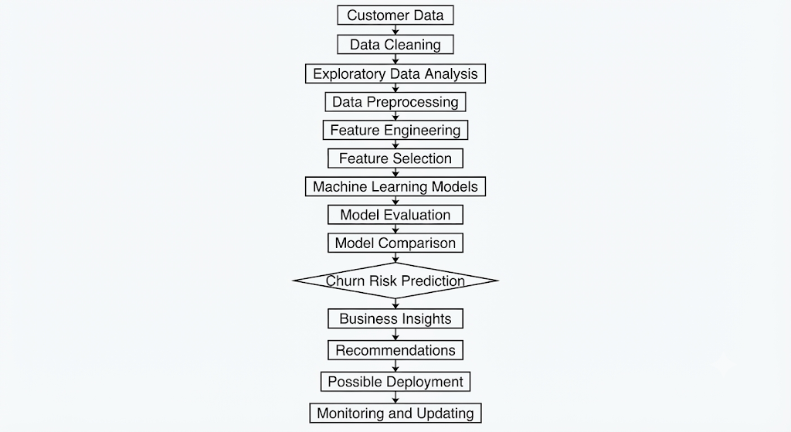
This flowchart summarizes how the technical analysis can eventually be converted into useful business information.

27. Project Timeline
A total of approximately 33 hours can be planned for preparing the complete report and presentation strategy.

Activity | Estimated Time
Review project objective | 2 hours
Methodology review | 4 hours
Analysis and insight planning | 6 hours
Visualization planning | 5 hours
Recommendations | 4 hours
Presentation strategy | 4 hours
Future work and limitations | 2 hours
Documentation and final review | 6 hours
Total | 33 hours

28. Conclusion
This report presents a comprehensive plan for communicating the results of a customer churn prediction data science project. The project combines data analysis, visualization, machine learning and business communication.
The proposed approach begins with understanding customer information and continues through data cleaning, exploratory analysis, machine learning and model evaluation. The analysis can be used to identify customer groups that may have a higher risk of churn.
Hypothetical examples in this report show how findings such as customer tenure, support requests, monthly charges and plan type could be presented to business stakeholders. Appropriate charts and tables can make these findings easier to understand.
The report also focuses on communicating technical information to non-technical audiences. Instead of concentrating only on model performance, the presentation should explain what the findings mean, why they matter and what actions could be taken.
Since no real dataset was provided, all findings, percentages and examples in this report are illustrative. A real implementation would require an actual dataset, model training, evaluation and validation before making business decisions.
Overall, the proposed workflow provides a structured way to convert customer data into understandable insights and practical recommendations while keeping data science as a support tool for business decision-making.

